🧠 Types of Parsers
# Source: AI Source: Provided by: [Data Path: Persons Table -> ID Column: 1, Name_En Column: Motasem Essam] -> From: [Chatgpt (GPT‑5 Mini)] on [1/26/2026]
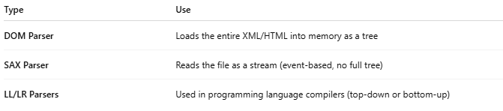
Type | Use
DOM Parser | Loads the entire XML/HTML into memory as a tree
SAX Parser | Reads the file as a stream (event-based, no full tree)
LL/LR Parsers | Used in programming language compilers (top-down or bottom-up)

